**6.2 Development updated.**

Where users can upload the PDF files only and there is limitation up to 5 MB. And it does not upload if any executable files like .exe change in .pdf format. It does not support and try to upload pdf format otherwise It gives the error message.

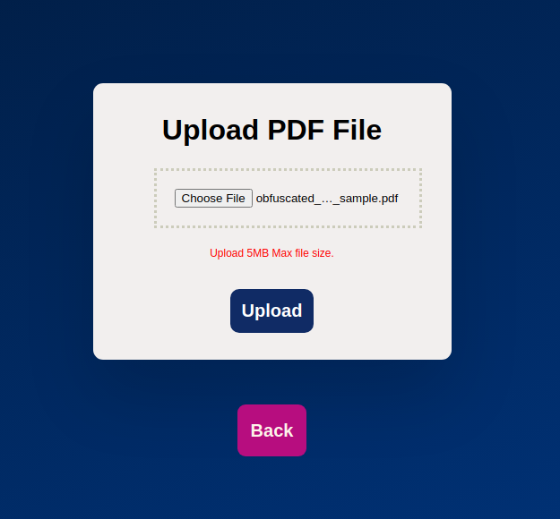

Fig.Upload PDF Files

Now we can check from the checkbox to select the PDF which files we want scan.

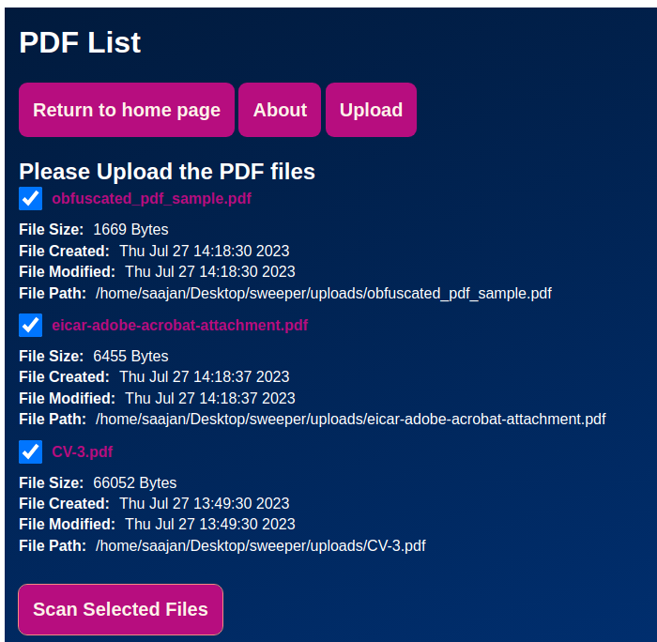

Fig.PDF list

Results as an output in front-end part it shows the two things does it detect by clam AV and match a yara rules.

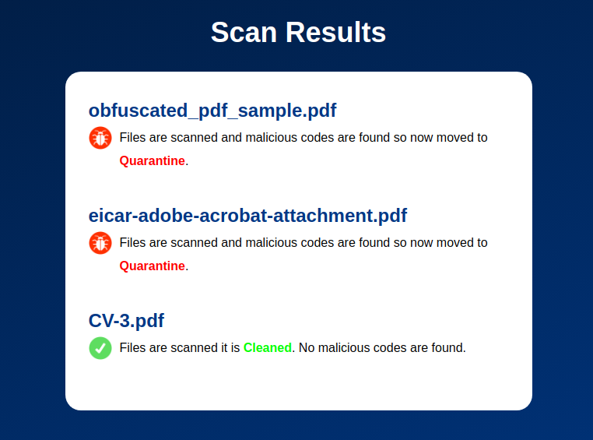

Fig.Scan results of PDF files